**18/03/2020 ATHAVALE CLASSES**

**Time:- 45 min Logic Marks:- 60**

1) Which of the following quantified statement is true? a) The square of every real number is positive b) There exists a real number whose square is negative c) There exists a real number whose square is not positive d) Every real number is rational

2) Form the disjunction of the following simple statements. p : The sun shines, q : It rains.

a) The sun shines or it rains b) The sun shines and it rains

c) If the sun shines then it rains d) none

3) Write the negation of the statement P: Mumbai is a city.

a) Mumbai is not a city b) It is not the case that Mumbai is a city

c) It is false that Mumbai is a city d) All the above

4) The inverse of the logical statement ‘’ If Ram is rich then he is happy ‘’ is

a) If Ram is not happy then he is not rich b) If Ram is not rich then he is not happy

c) If Ram is happy then he is rich d) Ram is rich and he is not happy

5) Which of the following statement are not logical statement.

a) Mumbai is capital of India. b) Latur is capital of India .c) 12 + 22 = 32 d) shut your mouth.

6) State the truth table of

a) T, T, T, T b) F, T, F, T c) T, T, F, T, d) F, F, F, T

7) Write the given statement in symbolic form ‘’A necessary condition for it to be cold is that it rains‘’ when p denote ‘’It is cold” and q denote “It rains”

a) b)  c) d) none

8) The negation of is a)b) c) d) none

9) If the compound statement is true for all its components, then the statement is called.

a) Contigent b) Contradiction c) Tautology d) None

10) Find out which are statement and which are not?

1) The real number p is less than 3 2) Two non empty sets have always a non – empty intersection. 3) Keep your mouth shut

a) 1 is a statement, 2 is not statement b) 2 is statement, 1 and 3 are not a statement

c) 1 and 2 are statements, 3 is not a statement d) all are not a statements

11) Consider the switching circuit given below:

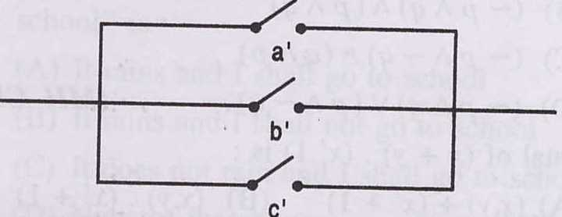

The logical expression corresponding to the complementary to the above circuit is:

a)  b)  c) d)

12) The output of the following circuits is:

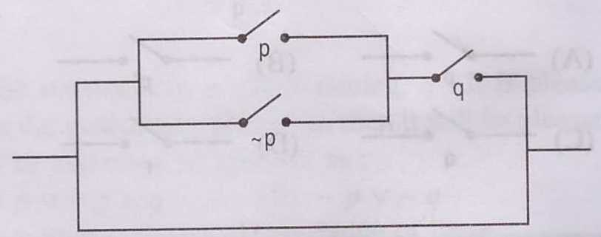 a) b)  c)  d) 

13) Which is of the following is not a statement. a) Sum of linear pair of angle is 1800 b) Asia is a continent. c) What a beautiful girl is? d) The sun is a star

14) Which of the following is the inverse of the proposition? “If a number is a prime, then it is odd” a) If a number is not a prime, then it is odd b) If a number is not a prime, then it is not odd

c) If a number is not odd, then it is not a prime d) If a number is odd, then it is a prime

15) Negation of (p v q) Λ r is a) ( ~p Λ ~q) v ~r b) ( ~p Λ ~q) Λ ~r c) ( ~p v~q) Λ ~r d) ( ~p v ~q) v ~r

16) If ( p v q) is true but [ ( p v q) →q ] is false, then truth values of p and q are respectively

a) T, F b) F,T c) F,F d) T,T

17) Solution set of the inequalitiesandis

a) a set of points which lie below the line y = 1 b) a set of points which lie on the line y = 1

c) a set of points which lie above the line y = 1 d) a set of points which lie on and above the line y = 1

18) Objective function of a L.P.P. is ….. a) a relation between the variables

b) a constraint. c) a function to be optimized d) a non-negative constraint.

19) Let t be a tautology and c be a contradiction Determine which of the pairs of statements are logically equivalent 1. 2. 

3. a) 1 and 2 b) only 2 c) 2 and 3 d) 1, 2 and 3

20) The logical statement of the circuit is

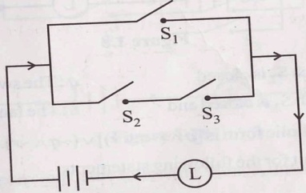a) b)  c)  d) 

21) Which of the following are logical statements

1) x + 5 = 21 2) sin x > 1,  is measured in radians

3) he stood first in the class 4) all differentiable functions are continuous

a) 1 and 2 b) 2 and 4 c) 1, 2 and 3 d) All the above

22) If p and q are two statements, then the conditional statement is false when

a) Both p & q are false b) Both p & q are true c) p is false & q is true d) p is true & q is false

23) Let p be the statement ‘’It is cold’’ and q be the statement ‘It is not raining’ Give verbal

sentence of .:- a) It is cold and raining b) It is cold or it is not raining

c) It is cold or it is raining d) It is not cold and it is raining

24) A compound statement p or q is false only when

a) p is false b) q is false c) both p and q are false. d) depends on p and q

25) Make the negation of the statement, ‘’It is false that sum of the angles of a square is”

a) sum of the angles of a triangle is not  b) sum of the angles of a triangle is greater than 

c) sum of the angles of a triangle is less than  d) sum of the angles of a triangle is 

26) Inverse of the converse of is :- a)  b) c) d)

27) Which of the following pairs of statement are logically equivalent.1) 

2)  3) 4) :-

a) 1, 2 b) 1, 2, 3 c) 2, 3, 4 d) All

28) Which among the following is equivalent to ?

a) b) c) d)

29) If p,q and r are any three logical statements, then which one of the following correct? a)  b) 

c)  d) 

30) Converse of the statement “If a number x is even. then x2 is even” is a) if a number x2 is even, then x is even b) if x is not even, then x2 is not even

c) Neither x nor x2 is even d) None of the above